## Accessing the Layer Tools

The layer tools are all housed on the Layers palette. From here you can select each of the layer functions and rename any layers that you need to. If the Layers palette is not visible just below the Properties palette, simply click on **View** > **Layers List** box from the main toolbar.

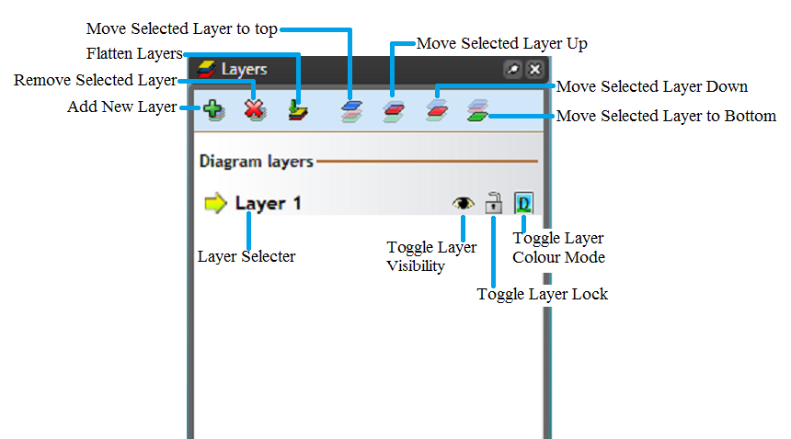

The_Layers_Palette_details

**Note**: Hovering over each icon will explain their functions